**GAME DESIGN DOCUMENT**

**The Depths**

**Simo Janhunen 0507629**

**Game Design Document**

* **Define your own game idea with minimum of 1-3 sentences per point.**
* **Consider the developed game from the viewpoint that you are actually making something which will be published at the end.**
* **Focus on the aspects 1-4, others you can define in more general terms since this is only the intro course into game development.**
* **The main aspects you are defining here are the following:**
  + **What would you like your game to look? Search or draw some concept art for your game, levels and characters.**
  + **What is the player doing in the game, what are the abilities of the characters?**
  + **What technological demands or requirements do you have? What technical aspects have to be solved for your idea to work?**
  + **What will your interface look like? What control scheme are you using and how does it work?**

**1. Executive Summary, Quick overview**

A Hack ‘n’ slash 2D platformer that is based on an unknown planet, which is inhabited by strange monsters. The main characters job is to fight his way through the depths to find out what is down below.

**2. Target Audience**

Anyone who likes 2D platformer games, all ages. Art style is going to be pixel-style without any blood splattering.

**3. Main Characters**

A yet to be named futuristic Asian themed swordsman.

**4. Main Features**

4.1 Main mechanics

Killing monsters. Responsive and fun movement. Navigating through the depths while stumbling into monsters.

4.2 Movement

Vertical and horizontal movement.

4.3 Physics

Earth-like gravity and “snappy”, fast-paced physics meaning fast-paced.

4.4 Multiplayer mode

None planned, local multiplayer with DLC.

**5. Genre, Setting, Concept Art book\***

2D hack ‘n’ slash platformer, based in unknown planet in outer space with reddish black eerie theme.

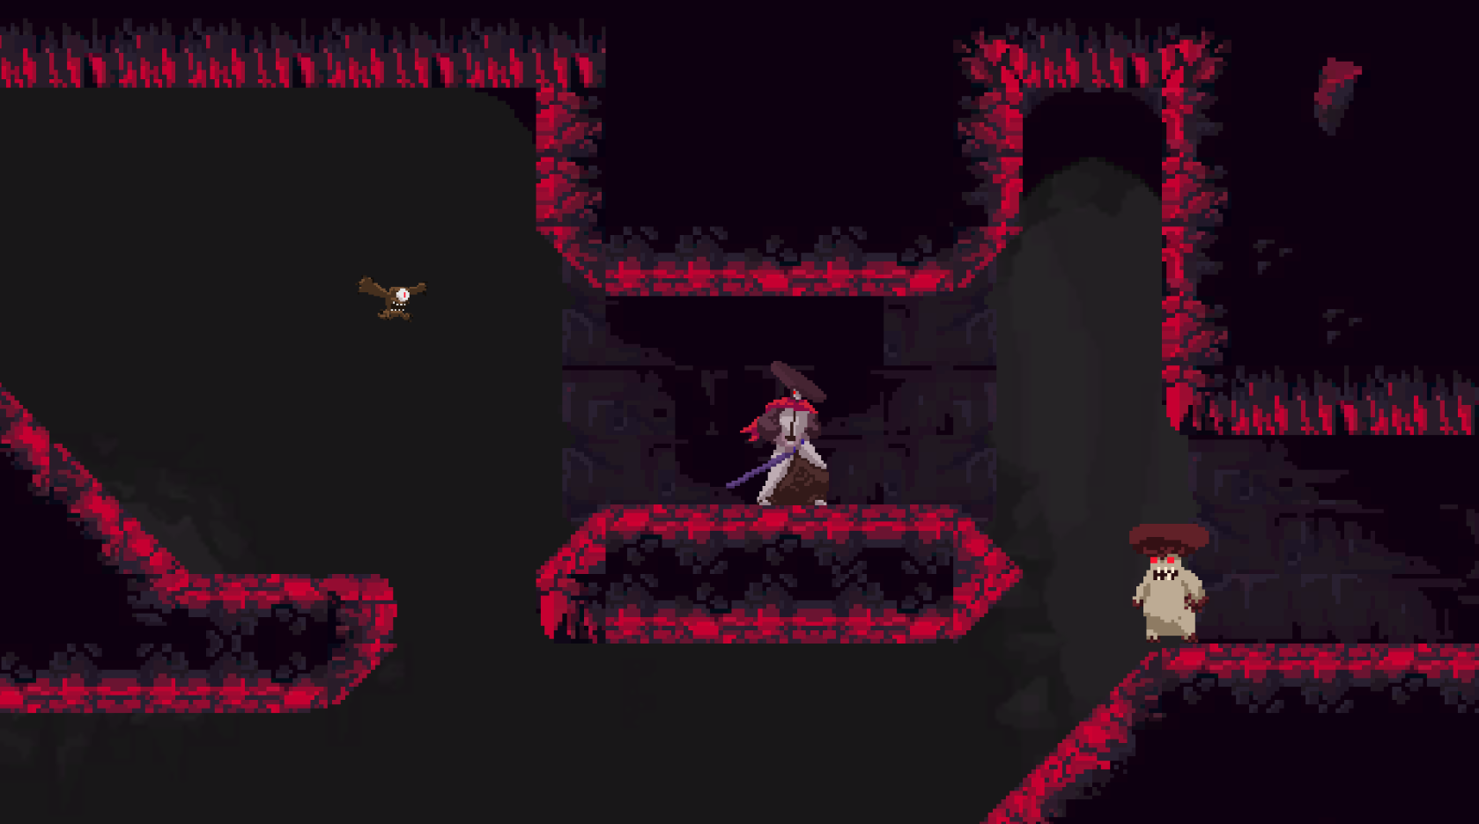

**6. Enemies, NPCs, Other objects**

Planning on 2-3 enemy types that exhibit several types of attacks/responses. Possibly NPC for early tutorial stuff.

**7. Story board, script\***

7.1 Story overview

Main character hacks his way to the bottom of The Depths in search of answers. Details of the story are still under consideration.

7.2 Progression, World 1

Tutorial world, where player is instructed with controls.

7.3 Progression, World 2

Actual playable level with complex tunnel structure, entrance for the actual Depths.

7.4 Progression, World 3

Boss monster room or another ending for the adventure, depends on the story ended up on.

**8. Technical definitions, Tech guide\***

8.1 Platforms, versions

Planned only for PC, Mac and Linux

8.2 Control Scheme

Arrow keys for directions, space for jumping, Z, X and C for attacking and interacting.

8.3 Limitations

Art will be most limiting factor as I have almost zero skills in photo editing as seen from concept art above. Making movement precise and responsive might be the biggest challenge programming wise.

**9. Business definitions\***

9.1 In-app purchases

No in-app purchases planned.

9.2 DLC packs

DLC packs for additional depths and weapons is planned. Local multiplayer.

**10. Outsourced/Bought Assets**

Most art used is going to be freeware from unity asset store or opengameart.org, no plans for bought assets.